Citywide Administrative Services Review

Framework Plan
February 1, 2001

Public Information/ Public Involvement

Table of Contents

Executive Summary 4
I. Introduction 6
A. Service Description: 6
B. Budget and Service Trends: 8
C. Results from Cost Reduction Phase: 9
D. Additional Recommendations 11
II. Business Environment and Strategic Vision for Service Delivery 12
A. PI/PI Vision and Core Values: 17
B. ONI Mission and Strategic direction: 18
III. Service Policies 19
A. City Code 19
B. Council Resolution: 19
C. Survey of other cities: 20
D. ONI’s role as policy leader: 21
IV. PI/PI Organizational Structure 22
A. Current structure 22
B. Proposed alternative structure 22
C. What would change? 23
D. ASR PI/PI Team Concerns: 24
V. Roles and Responsibilities 25
A. Bureaus as lead agents: 25
B. Office of Neighborhood Involvement (ONI). 25
VI. Service Provision Options 31
A. Recommendation 1: 31
B. Recommendation 2: 37
C. Recommendation 3: 47
D. Recommendation 4: 52
E. Recommendation 5 57
F. Recommendation 6: 57
G. Recommendation 7: 59
H. Recommendation 8: 59
I. Recommendation 9 60
J. Recommendation 10: 60
VII. Service and Performance Standards 62
A. Few Service and Performance Standards: 62
B. Current Status 62
C. Mandates Driving PI/PI 62
D. Recommendation- 63
VIII. Technology 65
IX. Financial Issues 66
X. Implementation Overview 67
A. Key Issues: 67
B. Timeframes for implementation: 67
C. Evaluation of any PI/PI administrative changes: 68
Appendices

- Sample PTE Contract and Purchasing Guidelines
- ONI Sample Database Screens
- City of Seattle Neighborhood Calendar Web Pages
- PI/PI Proposal Implementation Timeline
- PI/PI Activities/Workload Matrix
- Proposed CIP Public Communication Fact Sheet Template
- IAP2 Code of Ethics

Executive Summary

Public Involvement and public information (PI/PI) are central to the City’s mission, values, and programs. Citizen participation in civic decisions are at the heart of what makes Portland one of the most livable cities in the world. As city staff and as neighbors, we pride ourselves in the ability to involve our co-workers, neighbors, businesses, and community partners in programs and decisions.

On May 3, 2000, the Portland City Council amended the City Code to reorganize administrative service functions to provide for efficiencies and accountability. The action also directed the Chief Administrative Officer (CAO) to begin a citywide review of administrative services (ASR). PI/PI was included as one of the 15 areas requiring administrative review.

From September 2000 to January 2001, a team of PI/PI leaders, experts, and volunteers (ASR PI/PI team) met to discuss the PI/PI area and develop cost reduction recommendations as required in the ASR. An initial Cost Reduction Report was presented to the CAO on December 1, 2001 and included four main recommendations reaching the $452,340 target reduction, a “Minority Report,” questioning these recommendations, and a list of issues and concerns raised by the ASR PI/PI team.

This Framework Plan Report:
- Provides details and implementation plans for the four original recommendations provided in the December 1 Cost Reduction Report.
- Includes six additional recommendations coming from the “Minority Report” that merit discussion and inclusion.
- Identifies specific areas where clarification, Council direction, and decisions are needed.

There was tremendous dedication, collegiality, and agreement with the broad issues among the ASR PI/PI team. However, the ASR PI/PI team struggled throughout the process with inclusion of PI/PI in the ASR, ASR goals, ASR process and guidelines, and the ASR target reduction figures.

There indeed was wide agreement on the core values and principles of sound public information and public involvement. At this time, however, the team struggles and has concerns with the specifics of any direct changes or immediate cost reductions. There was little consensus on the specific recommendations in the December 1 Cost Reduction Report; this was witnessed directly in the “Minority Report. So while the Report includes many recommendations, details provided for Recommendations I-IV should not be construed as having unilateral agreement. General problems with moving forward with clear, agreed-upon changes in this area include:

- Lack of citywide standards, policies, and procedures for public involvement and public information;
- Inability to gather data on current services because of lack of databases, to track PTE contracts, and to get a clear picture of FTE designated to this area, and;
- Lack of clear definition of the role of the Office of Neighborhood Involvement in the city’s public involvement and public information administration.

As the Framework Plan Report phase continued, a critical intervening factor for any administrative changes that emerged was that PI/PI in Portland is central to every bureau’s goals and mission and currently the administration of PI/PI is very decentralized with very few citywide policies, standards, or direction. Consequently, a key implementation issues for any administrative changes in public involvement and public information include:

- The establishment by Council of standards, policies, and procedures for public involvement and public information.
- Clarification of the public involvement and public information role of the Office of Neighborhood Involvement (ONI)
- Decisions about which parts of public involvement and public information are central administrative services and which are bureau specific direct services.

Introduction
The ASR PI/PI team meet from late December 2000 through January 31, 2001 to discuss, augment, expand, and provide details to the original cost reduction presented on December 1, 2000 to OMF. The goal was to provide more information and detail on how the city could and should approach cost reductions and service efficiencies in the area of public involvement and public information.

As we continued to meet, it was clear that public involvement and public information is critical to the City’s work. The dedication, expertise, and experience of the city staff, community partners, and neighbor volunteers are readily apparent. All team members felt that the PI/PI area has potential for improvement, coordination, efficiencies, and possible cost reductions. And everyone feels that continued conversations would be beneficial.

As this ASR process proceeded, our charge, purpose, and goals (and the source) were to:
- Improve public involvement and public information for citizens and bureaus. (ONI)
- Look at “new ways of doing business” (OMF)
- Ensure the City is doing these administrative and support functions in the most efficient and cost-effective manner (Council)
- Explore how technology could improve public involvement and public information administration (OMF)
- Meet target reductions—about 5.8% cut (Council)

As required, this Framework Plan Report:
- Provides details and implementation plans for the four original recommendations provided in the December 1 Cost Reduction Report.
- Includes “suggestions, concerns, and ideas from the “Minority Report.”
- Provides additional recommendations for service delivery options and improvements.
- Identifies specific areas where clarification, Council direction, and decisions are needed.
- Elaborates on concerns that were raised in the Cost Reduction Report.

Service Description:
For purposes of the ASR, the public information/public involvement (PI/PI) service area included: public involvement outreach (both City-supported efforts and outsourced contracts), information and referral functions in ONI, Police Bureau (PPB), and the Bureau of Emergency Communications (BoEC), media relations, crime prevention, mediation services through ONI, neighborhood outreach, public information, and public relations.

Definitions: For the ASR, the following PI/PI definitions apply:
- Public Information: Fact-based educational tool, usually little opportunity for public feedback. Public learns from information they are provided. Purpose is communication, often of specific messages.
- Public Relations: Marketing tool used to promote public understanding an organization. Shines a positive light and gives company a positive image in the public eye.
- Public Education: Provision of information and programs designed to inform the public, provide background history and information, and increase their knowledge, skills, and abilities to understand a specific situation or topic.
- Public Involvement: Involves the public by requiring active participation and a feedback loop. Public is encouraged to provide feedback and participate in development and the decision making process. Public involvement is a process whose outcome is shared power.

This ASR team focused primarily on public involvement, administration of some public information services, and public relations. ONI is often involved in all of these functions on a citywide basis; however, the primary direction currently comes from the individual bureaus.

Shared concern with ASR definitions
One of the critical factors that drove discussion, disagreement, the “Minority Report,” and building coalition concern (and potential opposition to any ASR recommendations), is the basic assumption of this ASR process—Should PI/PI be included in the ASR cost reduction requirements?

To fairly represent the ASR PI/PI struggle to develop recommendations, this concern must be stated up front. All Bureaus participating in this ASR process argued that PI/PI should be defined as a direct service.

Besides the general concern about PI/PI being included in ASR, there were several specific-bureau concerns expressed:

ONI has argued consistently throughout this process that crime prevention, neighborhood coalition budgets, mediation services, and I&R services are direct services and not administration. ONI has considerable concern that the majority of its budget is included in the ASR target amounts.

OPDR has expressed concern that the 22.7 FTE included represent, for the most part, front desk support staff providing direct service to the public.

PPB has questioned the inclusion of 48 FTE in the ASR figures.

Budget and Service Trends:
Budget and position information for the Public Information/Public Involvement function was gathered through the initial ASR survey. The city wide budget figure (the basis for the 10% target reduction) is $7,798,783, and includes funding for 122.4 FTEs. Table #1 contains the budget and FTE amounts by bureau.

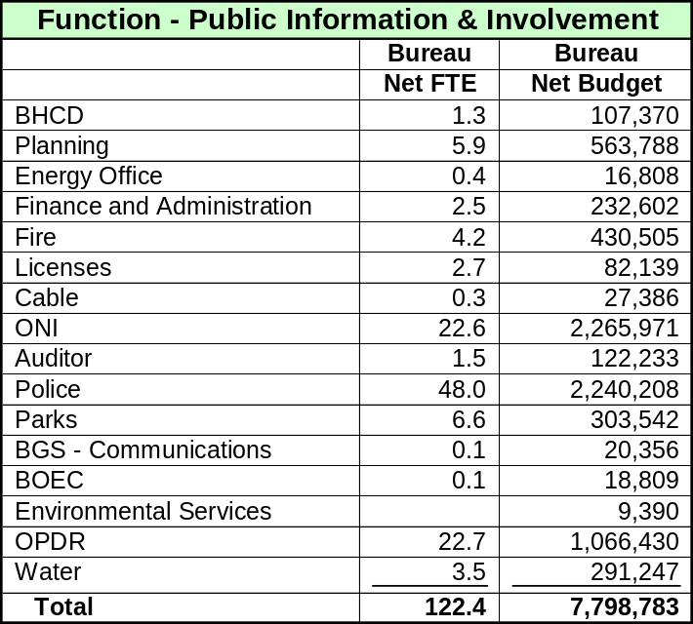
Note – Although these are the best figures available, many bureaus and several members of the PI/PI ASR Team do not agree with these figures due to the difficulty of dividing and shifting duties into percentages of each position.

Recent trends in budgets, positions, resources, and service provision:
Over the last three years, budgets for public information and public involvement have remained relatively stable with no major increases, except as dictated by specific projects or new targeted programs. For instance, FTE in ONI have increased; however, these FTE are specific PI/PI staff dedicated to crime prevention, residential siting, and liquor license notification. BES has provided funding to ONI for 3.0 FTE for public outreach in specific CSO project areas.

When surveyed, 2000-01 Budget documents identified 37 FTE in primary PI/PI roles; however, ASR PI/PI team members disputed these numbers. Buraus typically fund PI/PI as part of CIP projects; few full-time “general” PI/PI FTE exist in the City outside of 1.0 in Planning, 1.0 in Parks, 3.0 in BES, and 2.0 in ONI. In general, ASR team members felt that most PI/PI functions are integrated across projects within Bureaus rather than within specific FTE. The ASR data collected from Bureaus would support this given that the majority of the 122 FTE identified were small fractions of numerous FTE.

Specifically, Coalition budgets--a primary public involvement mechanism for the City since 1974 and funded through the Office of Neighborhood Involvement (ONI)--have remained flat. Some specific highlights in the PI/PI area:

Council asked the Planning Bureau to coordinate planning for projects on the Willamette River—River Renaissance Project

ONI has increased its trainings for neighborhood activists and community partners.

OPDR has worked with ONI to notify coalition offices about land use decisions.

Water, BES and ONI partnered with the Coalitions to provide opportunity for public input on the sewer rate reforms

Parks has initiated a major citizen involvement effort in their Parks 2020 Visioning Plan.

BHCD and PDC have partnered with neighborhood coalitions are specific urban renewal and target areas.

BES/ONI have increased their partnerships for public involvement with BES providing content expertise and funding and ONI providing staff and public involvement expertise.

PDOT/ONI have partnered on a traffic calming public involvement summit.

The majority of PI/PI continues to be done through decentralized efforts at the Bureau level. Any coordination efforts are voluntary rather than standard practice.

On November 20, 2000, the County I&R services were merged into the City I&R services, increasing the scope of the service and the capacity of the ONI I&R Center to handle a wide variety of city/county calls.

PPB/ONI have increased their partnerships in major public involvement efforts with the Mayor's Office through NeighborSafe and with the Block Captain program

Results from Cost Reduction Phase:
On December 1, four recommendations for service delivery improvements and cost reductions were forwarded to OMF:

Improve coordination, monitoring, and dissemination of public involvement professional contract dollars outsourced to consultants.
This voluntary improvement would increase the City’s capacity to:

Build inter-Bureau partnerships on public involvement projects

Set up a consultation loop process

Track PTE/public involvement projects

Maximize use of existing resources including ONI and Coalitions

Coordinate administration of the majority of public involvement/public information meetings, trainings, involvement opportunities, and policies in ONI.
This would include transferring the responsibility to ONI for:

Developing, maintaining, and utilizing common stakeholder identification databases with citywide availability.

Coordinating dissemination of general announcements, information, facts, to neighbors, business, stakeholders, and others about an issue, event, proposal etc. (Notifications required by City Code, State Statute, etc. would be retained by the Bureau although a common database could be used.) New services for Bureaus could include ONI:

Developing a citywide PI/PI calendar.

Developing electronic dissemination methods.

Developing flyers for meeting announcements.

Disseminating meeting agendas where appropriate.

Disseminating meeting minutes if necessary.

Coordinating most public meetings. New services for Bureaus could include ONI:

Facilitating Bureau organization of public meetings.

Establish protocols with each Bureau around their needs for regular public involvement meetings.

Provide Bureaus with standardized meeting request information.

Arrange for rooms, locations etc.

Coordinate meetings with other Bureaus, coalitions, existing meetings, etc.

Arranging, coordinating, and advertising meetings through a citywide newsletter or calendar.

Coordinating public involvement and education opportunities.
Since public involvement administration would be better coordinated through this recommendation, ONI would increase its ability to:

Develop, coordinate, facilitate, and maintain citywide training for the public on general civic topics and specific Bureau topics involving general information.

Coordinate public information and education opportunities for the public on specific topics.

Develop citywide public information and education opportunities.

Support City efforts to coordinate strategic planning and planning opportunities in order to maximize public involvement and minimize duplication of effort.

Providing bureaus with consistent citywide public involvement policies, and procedures.

Providing strategic development services for Bureaus including:

Identifying the issue.

Assessing stakeholders and project impacts

Identifying public components within the project scope.

Identifying the most appropriate outreach method.

Writing program proposals.

Detailing a project schedule for public involvement.

Assessment and evaluation

Consulting on strategic changes and direction for projects.

Explore further consolidation of I&R functions within the City and increase the scope of the City/County I&R Center to relieve the Police Bureau of some I&R tasks.
Utilize enhanced technology for city staff directory and I&R needs to reduce City/County I&R FTE.

Create a citywide Public Information/media relations position for the City.

Additional Recommendations
In addition, the following additional recommendations were put forth from the team. They were not received in time for inclusion into the full December 1 report but were included in the “Minority Report” and distributed with the December 1 recommendations. Many have no identifiable immediate budget savings or cost reductions. However, they certainly merit attention and further exploration. More information will be provided in later sections.

Allocate target budget reductions to the affected bureaus based on overall budget, rather than FTE reductions.

CIP Coordination:

Encourage public involvement and outreach planning in the existing citywide CIP coordination effort. This will support development of collaborative public involvement/public information plans. Initiate a similar effort for other planning initiatives.

Establish a standard practice for development and implementation of collaborative public involvement plans in conjunction with the citywide effort to coordinate schedules for capital and planning projects by geographic area.

Encourage bureaus to consult with ONI on all public involvement processes and invite ONI to bid on all public involvement contracts.

Encourage ONI to coordinate a citywide discussion to develop common terms, understanding and expectations for outreach processes along with standard guidelines. of the variety and scope of existing programs.

Encourage ONI to coordinate a citywide discussion to explore development of a common stakeholder identification database with citywide availability.

Charge BIT and ONI to coordinate a citywide discussion on how bureaus might use information technology to facilitate public involvement and public information. This might also include exploration of “e-government” services to the community.

Business Environment and Strategic Vision for Service Delivery

Within the functional area of public involvement and public information, the major focus areas of system improvement included:
- Contracting for PI/PI consultation services
- Public involvement services
- Public information services

Figure 1 summarizes the real-world issues and trends, trends that will drive the support service over the next 3-5 years, and how this Framework Plan addresses these trends and issues. It is important that PI/PI trends tend to be driven by factors outside direct influence such as major projects, city directives, emergencies, etc.

Figure 1 – Public Involvement/Public Information - Business Environment and Strategic Vision for Service Delivery

 | Real-World Issues and trends | Trends that will drive the support service over the next 3 – 5 Years | How does Strategic Plan address these trends and Issues
Contracting for PI/PI Consultation Services | - Need for periodic, non-planned, “emergency,” services  - Need for on-going project-funded and mandated services  - Continued need for on-going regular PI/PI as part of City Bureau functions.  - Citizen desire to understand the organization of City government and services provided  - Problems resulting from poor PI/PI process or lack of PI/PI that leads to implementation difficulties  - Public expectation that the city communicate effectively and efficiently | - Increased population density and the effects of the Urban Growth Boundary on development  - Possible challenges with implementation of Measure 7  - Desire from citizens to coordinate city services within geographic area  - Project complexity will demand increased mobility and flexibility by bureaus  - Some PI/PI needs require expertise not contained within city staff  - Some PI/PI needs require outside perspective | - Inclusion of open competitive contract option with ONI  - Increase in availability of ONI services for Bureaus on volunteer basis to improve contracting process  - Stated desire to coordinate PTE services among Bureaus.  - Inclusion of PTE contracting tracking with Bureaus, ONI, and Purchasing.  - Improved PTE procedures through Purchasing ASR recommendations  - Increased compliance and monitoring of process and outcomes  - Coordinated and controlled delivery of information though better coordination and communication.
Public Involvement Services | - Continued City commitment to public involvement  - Continued on-going personnel and M&S costs at coalitions  - Increased pressure on Bureaus to conduct public involvement based on density issues, land-use, CSO, capital projects, etc.  - Continued need for mailings, notifications, postings, etc.  - Increased need to reach diverse populations through a consistent, dedicated strategy and mechanisms | - Possible mandates or directions from Measure 7  - General fund allocation towards public involvement through coalitions  - Increased desire for public involvement coordination for capital projects.  - Continued and increased pressure from citizens to be involved in public decisions  - Increased availability and use of technology including electronic communication  - Recognition and research that supports public involvement at beginning of a project saves time and money.  - Increasing demographic diversity  - Increasing number of mediums to communicate effectively with community  - Increased public awareness and involvement in environment and “quality of life” issues | - Improved central coordination of mailings and notification through ONI.  - Systematic use of electronic notification  - Web-based calendar development  - Citywide coordination of public meetings through ONI  - Assistance with stakeholder identification through ONI  - Consistent format of notification material  - Increased ability for bureaus to focus on content of information.
Public Information Services | - Continued need for public information from Bureaus, City/County I&R  - Needed inclusion of renters, people of color, and low income citizens  - Individual Bureau formats for notification documents that may be ineffective or confusing to engage citizens.  - Increased information available from Bureaus  - Existence of inter-Bureau partnerships that produce a cost savings and lead to early attainment of goals (e.g., Downspout disconnection program)  - Bureau programs and projects.  - Need for city to tell the “big picture” story to promote the city.  - Need to promote bureau projects through a common source | - Pressure from public to make information available “24/7”  - Stable and “flat” budget support from County  - Increased ability to put information and referral on the internet  - “Fast track projects” will reduce amount of time and resources that can be spent on public information | - Creation of central PIO to handle major City public relations issues.  - Development of web-based information and referral system.  - Coordination with BOEC and PPB to develop best I&R program for the City.  - Possible partnering with other outside agencies to increase I&R services by having “one-source” for metro area.

PI/PI Vision and Core Values:
During the framework development phase of the ASR team worked on developing core values for PI/PI. These core values are important as they frame any current and future discussions of PI/PI needs and changes. PI/PI team members worked with Howard Schussler from BHR to develop a vision and core values for public involvement and public information in the City. These included:
- Community members will be involved
- Open, fair process
- Input will be utilized
- Consistency in policy and methodology
- Understandable by community
- Opinions and the public role is respected
- Engaging the diversity of Portland’s population
- Involvement must be relevant
- Hearing the voice of the community
- Public involvement adds value and improves community
- Customer service mindset
- Every voice should be heard and respected
- Balance the needs of the stakeholders with the context of the system
- Accurate information for the creating sound decisions
- Follow-through /feedback/close the information loop
- Information easy for the public to find
- Responsive relationship with the media
- Proactive information sharing
- Consistent quality
- Professional quality products
- Appropriate for audience and the internal needs of the organization
- Involvement and information in context with other efforts

Other PI/PI values:
- The International Association of Public Participation (IAP2)—a professional member organization of public involvement and public information--has the following core values:
- The public should have a say in decisions about actions that affect their lives.
- Public participation includes the promise that the public's contribution will influence the decision.
- The public participation process communicates the interests and meets the process needs of all participants.
- The public participation process seeks out and facilitates the involvement of those potentially affected.
- The public participation process involves participants in defining how they participate.
- The public participation process communicates to participants how their input affected the decision.
- The public participation process provides participants with the information they need to participate in a meaningful way.

ONI Mission and Strategic direction:
See Section V “Roles and Responsibilities” below for discussion of ONI’s mission and strategic direction for PI/PI.

Service Policies
Many individual bureaus have their own PI/PI policies. However, there are very few citywide policies that govern the work of PI/PI in the City. There is:

City Code
City Code Chapter 3.96 sets out functions, duties, and responsibilities for the Office of Neighborhood Involvement including:
- Notifying interested persons of meetings, hearing, elections, and other citizen participation events;
- Assisting neighborhood associations and district coalition boards and others in planning and developing programs for citizen participation, crime prevention, dispute resolution, and citizen budget review.
- Acting as an information clearinghouse and resource to neighborhood associations, citizens or other groups;
- Promoting and facilitating open communication among City agencies, neighborhood associations and district coalition boards;
- Supporting and promoting citizen involvement within the neighborhood association framework;
- Adopting and revising such guidelines as are deemed necessary for the implementation of this Chapter and for orderly citizen participation in City government through neighborhood associations and district coalition boards. In so doing, the Office of Neighborhood Associations shall involve neighborhood associations and other interested citizens as necessary.

Council Resolution:
In 1996, Council passed the following resolution (listed on the following page):
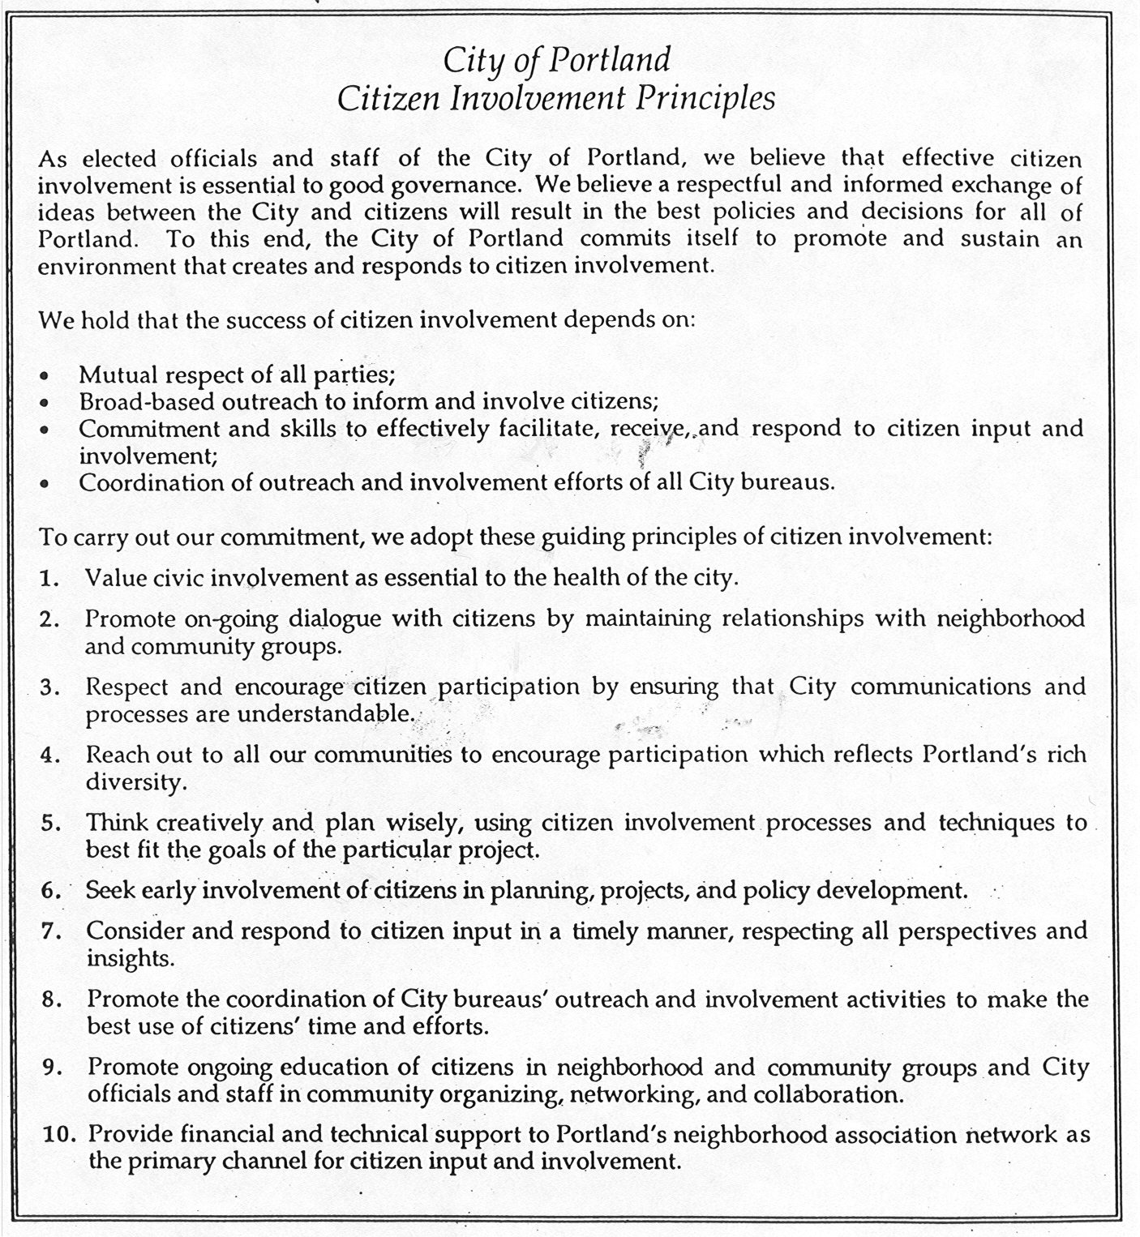

Survey of other cities:
Given the unique way that Portland provides PI/PI services, it is problematic to find other comparative data. Portland’s neighborhood system, the Office of Neighborhood Involvement, and public outreach efforts by Bureaus are typically cited as the model and expert on public involvement.

The only other data suggested was to look back at the cities (in addition to Portland) compared in Ken Thompson’s The Rebirth of Urban Democracy and compare these cities’ progress on PI/PI. We attempted to contact these cities, but did not receive any significant feedback or examples of policies.

During the ASR process, ONI also contacted the following cities for any examples they had on PI/PI policies: St. Paul, MN; Seattle, WA; Madison, WI; Dayton, OH; Little Rock, AR. No standardized policies were uncovered. Given the short timeframe of the ASR process, it is possible that further time would uncover other policies.

ONI’s role as policy leader:
ONI has always been seen as a policy leader for guidance and maintenance of recognition of neighborhood associations, coalition contracts, and monitoring of compliance with the City’s “Guidelines for Neighborhood Associations, District Coalitions, Neighborhood Business Associations, Communities Beyond Neighborhood Boundaries, Alternative Service Delivery Structures and the Office of Neighborhood Involvement” (Adopted by City Council, 1/7/98).

Over the past several years, ONI has attempted at different times to coordinate citywide PI/PI processes. Coordination efforts have included :
- Public involvement coordinators network for city staff (currently called C-PIN—Citywide Public Involvement Network)
- Citywide outreach calendar (published monthly)
- Citywide bureaus-events calendar
- Neighborhood meetings calendar (published monthly)

While these efforts are useful—and would be continued if the ASR recommendations outlined here are implemented—these have been done by ONI based on staff-availability. More importantly, ONI’s role in these efforts has not been clearly defined by the City and efforts to coordinate have based on voluntary, time allowed, basis by bureaus resulting in incomplete calendars that are not widely distributed.

PI/PI Organizational Structure

Current structure
Presently—with few exceptions—PI/PI is de-centralized within each bureau. All public involvement processes and functions are directed separately by the bureaus. As mentioned above, ONI ability and efforts to coordinate citywide policies, calendars, and outreach efforts—while appreciated by bureaus—have fluctuated based on ONI staff, provision of timely and regular information by bureaus, and participation by bureaus.

Coalitions are contracted with ONI to “improve livability, sense of community, and the sense of safety in the City of Portland by utilizing citizen participation and self-empowerment at the neighborhood level through a variety of functions. Goals to be achieved via the contract include enhancing citizen participation; increasing the number of citizens involved in neighborhood livability issues (including crime prevention); facilitating the maintenance eof effective neighborhood associations within the target area helping assure that neighborhood associations reflect the needs and interest of their residents; and providing a communication link between and strengthening the interaction between neighborhood associations and the City” (language from our contract with Coalitions).

Proposed alternative structure
The proposed recommendations support the current system whereby bureaus direct their individual PI/PI decisions and processes. The recommendations also maintain the current coalition structure whereby coalitions can establish direct relationships with bureaus.

The recommendations clarify ONI’s role as a public involvement bureau and provide value-added administrative services for city bureaus to improve delivery of PI/PI in consistent, efficient, and cost effective ways.

Throughout this process, the goals of the Central Services Manager were to use the ASR to:

Explore ways to improve public involvement and public information services in the City.

Improve coordination for citizen communication

Improve partnerships among Bureaus

Define ONI’s role in the citywide PI/PI process and increase utilization of ONI skills, resources, and staff as appropriate

Increase connection with coalitions for possible partnerships

Develop mechanisms for the development of consistent policies, strategies, and implementation plans for PI/PI

What would change?
Under the proposed alternatives, bureaus would retain primary control and impetus for PI/PI. Coalitions would retain a strong leadership role for neighborhood associations. What the proposed ASR recommendations are designed to change, however, are value-added services so that the City and the bureaus have a:

Ability to develop consistent procedures, policies, and strategies for public involvement.

Better utilization of the coalition structure for outreach and partnerships.

Maximization of consistent information from the City and minimization of duplication (mailings, multiple bureau staff presentations, overlapping outreach, disconnection with the coalitions);

Clearer understanding and recognition of ONI’s role as the public involvement bureau.

Ability to provide coordinated information to citizens about Bureau activities and services.

Recommendations 1, 2, and 6 through 10 will require a cultural shift as ONI’s role is more clearly defined and its resources used on a more consistent citywide basis. Bureaus will be encouraged to continue current efforts and expand their efforts to coordinate public involvement services with ONI. This coordination will require a shift in Bureau culture as Bureaus partner with ONI to coordinate meetings, partner with other Bureaus on public involvement opportunities, use coalitions more, and work with ONI to develop citywide PI/PI policies and procedures. However, Bureaus should realize an increase in staff time available for content-specific projects as bureaus redirect staff time currently spent in public involvement administration toward other bureau and project-specific goals and tasks.

Implementation of Recommendation 3 will increase the centralization of information and referral services that the City began in 1995. By coordinating I&R functions among, ONI’s City/County I&R, the Police Bureau’s I&R, and BOEC, the city can work toward maximizing the use of information and referral databases, technology, and staff resources to provide the best service to citizens. For instance, by switching all social service calls from the Police Bureau to the City/County I&R Center, duplication of effort will be minimized. By increasing the use of web-based technology, I&R calls can be redirected to the Intranet for City staff. And by utilizing one citywide, web-based database, staff time used to research and maintain the information will be minimized.

Implementation of Recommendation 4 (PIO officer) will improve the City’s image and ability to provide positive, consistent media messages to the citizens. During times of emergency or crisis, the City has done this in the past. However, during the normal operations of the City, there have been many lost opportunities for City bureaus, elected officials, and staff to present positive images, information, and background on a myriad of public information opportunities. The addition of this position would help provide consistent public information for the City.

ASR PI/PI Team Concerns:
In our discussion of roles, one of the key concerns was that any shift toward centralization of any process functions within ONI is whether “content expertise” can be separated from “process expertise.” Frankly, their were advocates on both sides of the issues. The issue is whether this separation would detract from the City’s longstanding tradition of citizen participation and a feeling that “all” city staff—especially project management—have a responsibility for public involvement and public information expertise.

For many bureaus, it is also important to develop and nurture community relationships that endure past a project. Members of the team worried that having ONI play a more central administrative role would remove bureau staff from their ability to develop and nurture these roles.

Finally, coalition representatives on the ASR PI/PI team and coalition staff question whether any centralization through ONI would hinder their ability to develop direct relationships and partnerships with bureaus.

Roles and Responsibilities

Bureaus as lead agents:
As mentioned above, the bureaus primary role as lead agents directing PI/PI services would be maintained. Bureaus would continue their current roles of developing direct relationships, contracts, and partnerships with consultants, coalitions, and agencies.

What would possibly shift if these recommendations are implemented is the role of ONI and the administration of various administrative tasks. What also would change would be how the bureaus and city utilize public information services as a central PIO is developed.

Key Challenge:
City code (Chapter 3.96) seems to be clear in establishing ONI as the City’s public involvement bureau. However, the design, funding, and implementation of the majority of PI/PI services are currently decentralized; no bureau has a lead role in developing policy, developing, strategic standards, monitoring effectiveness, tracking PTE dollars, or standardizing services. Thus the discussion of any shifting or re-definition of roles was difficult.

ASR PI/PI Team Concern:
Because of the lack of clear roles, standard practices, definition of potential PI/PI problems, the ASR PI/PI team initially recommended a much longer study period to develop PI/PI recommendations. This desire for expanded time for discussion, of course, did not fit in with the ASR timeline.

However, as the possible cost reduction recommendations included in this report began to crystallize, one of the main responses—and subsequently a key challenge in the ASR PI/PI process—was defining current roles and responsibilities for ONI. However, one clear factor in this ASR process is that the difficulty of implementing any PI/PI administrative changes involving ONI is compounded by the reality that the current role of ONI is not clearly understood across the city or across the coalitions.

Office of Neighborhood Involvement (ONI).
The ASR process elicited numerous conversations, concerns, inquires, etc. among city staff, Council offices, coalition staff, coalition boards, neighborhoods, and other partners. The one indisputable fact is that no one, clear understanding of the role of ONI exists. Consequently, for the purposes of ASR, it is important for Council to define, clarify, and confirm--ONI’s role in public involvement and public information.

The Problem:
Part of the problem about lack of clarity of ONI’s role stems from the fact that the role, purpose, and mission of ONI has evolved over its 27 year history. Many city staff and citizens still refer to ONI as “ONA” and see its role as only dealing with neighborhood associations.

Original role:
Prior to 1997, the Bureau was called the “Office of Neighborhood Associations” (ONA) and its primary role was to administer and support the recognized neighborhood associations and district coalitions. Although, in one sense, the City Code expounds definite language regarding the bureau’s mission and function as a public involvement bureau, interpretation and implementation of the code has been unclear.

Change in role, functions, and name:
This original role of the bureau began to evolve immediately and has changed significantly in the last decade. Beginning in the late 1980’s and 1990’s, Council began to expand and broaden the role and configuration of the bureau by redirecting and administering other programs within ONA.

The additional programs added by Council over the last 20 years include the Neighborhood Mediation Center, Refugee and Immigrant Program, the Metropolitan Human Rights Center, the Information and Referral Program, and the graffiti abatement program. To reflect these additions of neighbor-based and bureau-directed programs outside of the traditional and historical ONA role and to broaden inclusion of our neighborhood system, a citizen task force in 1996 recommended that the bureau be renamed the Office of Neighborhood Involvement.

Recently, Council added the Community Residential Siting Program, the Liquor License Notification Program, and expanded the I&R program to include county services. These changes over the bureau’s history support the bureau’s evolving role as a full-service public involvement bureau for neighbor-to-neighborhood-to-coalition-to-bureau-to-neighborhood-to-coalition-to-neighbor work.

Recent Work on Vision, Mission and Values:
It was clear as the bureau entered the new millennium, there was still confusion, questions, and lack of clarity about ONI’s role. Under the direction of Commissioner Saltzman, ONI reassessed all of its internal functions and began an internal strategic planning process with staff. ONI in 2000 developed a new mission and reaffirmed the bureau’s values:

Mission
To enhance the quality of Portland’s neighborhoods through community participation.

Bureau values:

Establishing a climate of equality, respect and community empowerment

Promoting tolerance, understanding and mutual learning

Communicating respectfully

Engaging in collaborative community processes

Creating universal access

Advocating for fair and equal process

Providing service with integrity

Fostering community centered activism

Confirmation of public involvement expertise
ONI’s current mission is not a “new direction” for ONI but rather a confirmation of our role and vision as a full-service public involvement bureau that serves ALL of Portland’s neighbors, neighborhoods, businesses, and community partners. Further, ONI’s recent strategic planning was an effort to communicate our expertise in:

Public involvement outreach

Training and education of citizens and city staff

Multi-cultural education, training, and outreach

Information and referral

Neighbor-to-neighbor mediation

High stakes facilitation

Public safety communication, facilitation, and organization

Public involvement contract management

Role Changes from implementation of ASR PI/PI recommendations:

As mentioned above, implementation of these ASR recommendations would still:

Have the primary role of bureaus be the service provider for PI/PI.

Allow and encourage coalitions to partner directly with bureaus.

Maintain the current decentralized roles of bureaus in public involvement and public information

Have ONI be a value-added resource for bureaus

Continue funding for coalitions as a public involvement partner

What would shift—if these recommendations are implemented—is:

Clearer role of ONI’s public involvement function

Better utilization of ONI’s staff and expertise

Value-added services for bureau-directed PI/PI processes

Clearer understanding and delivery of information and referral services

Better public information services for cross-city issues, projects, and problems.

Figure 2 on the next pages depicts how the role of ONI and the Bureaus might look in the PI/PI field.
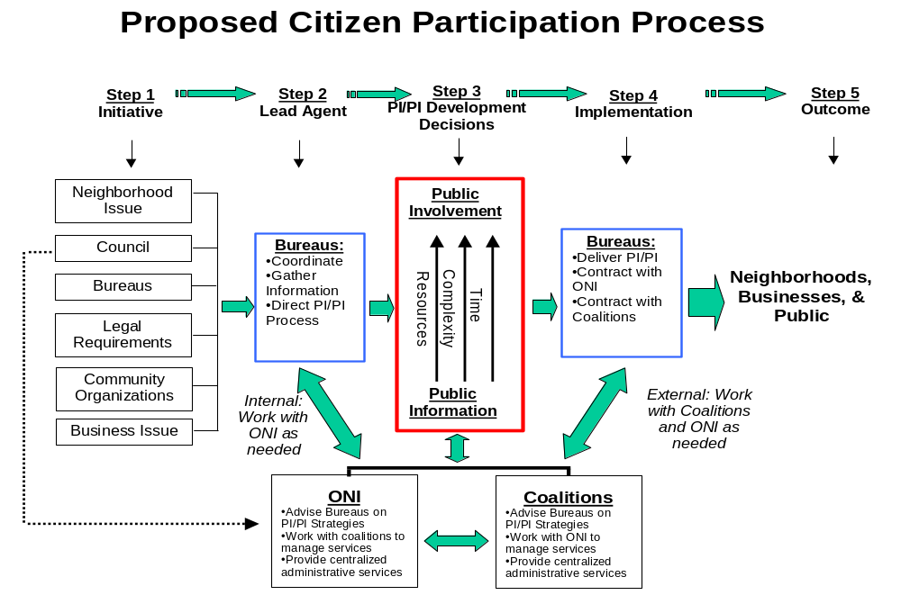
Figure 2. Proposed Citizen Participation Decision Process

Service Provision Options
This section will expand the definition and implementation protocols of the alternative services proposed in this report. The Central Services Manager was guided by two overriding objectives: to improve service delivery and contain and/or reduce costs.

Recommendation 1:
As re-defined during this phase, this recommendation would:
- Utilize ONI--as feasible and on a volunteer basis--to support coordination, monitoring, and dissemination of public involvement professional contract dollars outsourced to consultants.
- Encourage bureaus to confer with ONI on public involvement processes and invite ONI to work on all public involvement contracts.
- Work with Bureau of Purchasing to develop a system to identify and track all PTE contracts for public involvement and public information.

Figure 3 on the page 35 shows how implementation of this proposal would work. This recommendation:
- Asks for willing consultation with ONI from the bureaus on any public involvement contract
- Suggests that the bureaus discuss the scope and plans with ONI and be receptive to their suggestions and ideas and consider them as a reasonable first choice to do the contract
- Maintains the ultimate choice of the consultant and/or outside contract be at the discretion of the bureau.

Products produced for the bureaus :

ONI would develop an RFP for an “Open Competitive Contract,” often referred to as a “Bidder’s List” or “Prequalifying List” for potential consultants interested in bidding on Bureau public involvement and public information projects. Coalitions would be included and Bureaus would help develop the RFP to ensure its broad acceptability and maximization of interest and skills. An example of this type of contract, along with guidelines from Purchasing are included in Appendix I. Once the RFP is let and evaluated, ONI would :
- Develop a list of “pre-approved” PI/PI consultants that Bureaus could tap into as needed. This would save Bureau staff time and resources from developing individual RFPs.
- Make the list and services available to Bureaus.
- Be available for Bureaus to consult with to choose their PI/PI consultants.
- Work with Bureaus as necessary to negotiate scope of work and contract requirements.
- Be available through IGAs to administer the PI/PI process if desired

Increased tracking of PTE contracts. Bureaus have been directed by OMF to track PTE contracts. Purchasing is looking at system to track city funds that are used for PI/PI PTE contracts. To fully implement accurate, centralized tracking through Purchasing would require additional funding as indicated in the ASR report on Purchasing.) ONI would report to Bureaus and Council about amounts expended, types of services, cost savings incurred, and potential future cost savings.

Clearinghouse of public involvement contractors, city staff expertise, and skills available to support Bureau’s public involvement efforts.

Be available to work with Bureaus to review PI/PI contracts.

Value-added for the bureau:

Additional expertise in PI/PI through ONI to complement Bureau resources.

Savings in staff time to write, monitor, and evaluate RFP and contracts for limited PI/PI projects.

Faster response time for one-time or “emergency” PI/PI projects.

Opportunity for maximal use of ONI and Coalition services.

Retention of Bureau expertise and ownership through partnership arrangements rather than mandatory shifts.

Value-added for citizens:

Tracking and better accountability of public dollars used for PI/PI contracts.

System for reviewing and discussing PTE process.

Increased opportunities for Bureau partnerships.

Opportunity to increase numbers, types, expertise, and experience of potential City PI/PI consultants.

Process:

ONI, in partnership with Bureau of Purchases and Bureaus, develops RFP for “Open Competitive” contract.

ONI works with Purchasing to distribute, advertise, and evaluate responses.

ONI develops approved “Providers List” and distributes to Bureaus.

As needed, Bureaus contact ONI to discuss contract needs.

ONI advises Bureaus and Bureaus select contractor.

ONI works with Bureaus, as requested, to develop scope of work and contracts.

ONI tracks all of it’s own contracts for PI/PI and provides annual report with OMF to Bureaus and Council. If Bureau of Purchases funding for improved database capabilities allows for Centralized PTE tracking, could incorporate Citywide data from BOP database also.

Performance Measures:

Purchasing works with ONI to develop standardized “Open Competitive” contract.

Purchasing (contingent on funding) develops PTE tracking standards and methods. Information is provided to ONI for annual report.

ONI, Purchasing, and OMF produce annual report to Bureaus and Council about PTE contracts and process. This report would include: PI/PI PTE contracts (completeness depending on ability of Purchasing to track), processes involved, data on “open competitive contract” process, and areas of possible future savings.

Benefits of Recommendation 1:
Most of the following benefits and challenges were identified in Phase I of the ASR. Some of the original barriers and challenges have been ameliorated due to refinement and clarification of this recommendation during the second framework development phase.

Staff time to develop, implement, and review RFPs would be reduced as ONI would have a pre-developed and pre-approved “bidders list” that could be used quickly by bureaus as needed.

When appropriate, using ONI and coalitions for PTE contract resources could cost less.

Coordinated use of existing city resources including staff and expertise

More use of existing city support of neighborhood coalitions and offices

Integration of public involvement programs into existing city outreach efforts including coordination on CIP projects.

Better tracking of PTE contracts and consistent application and maintenance of quality public involvement standards.

Improved communication among neighborhoods, agencies, and city staff as consistent standards would apply.

Challenges for of Recommendation 1:

ONI would incorporate the additional staff proposed in Recommendation II below to implement this recommendation. Without additional staff, implementing Recommendation I would challenge ONI's current administration.

Bureaus would need to spend staff time with ONI to utilize the “opens requirement contracts.”

Some city projects would always need outside consultants. Therefore, ASR savings and ongoing savings are difficult to calculate.

Perception that ONI, coalitions, and neighborhood offices should have to bid for PI contracts just like outside vendors.

Coalitions might not want to take on any city PTE contracts because of “conflict of interests.”

Assumption that insourced public involvement contracts are based on current contracts that ONI and coalitions have. Future data and customer service review will be needed to further document this assumption.

There could be a “conflict of interest” for ONI (see further comments under Recommendation 7).

Public involvement contract dollars ebb and flow depending on the year and projects so any city staffing changes would have to consider this.
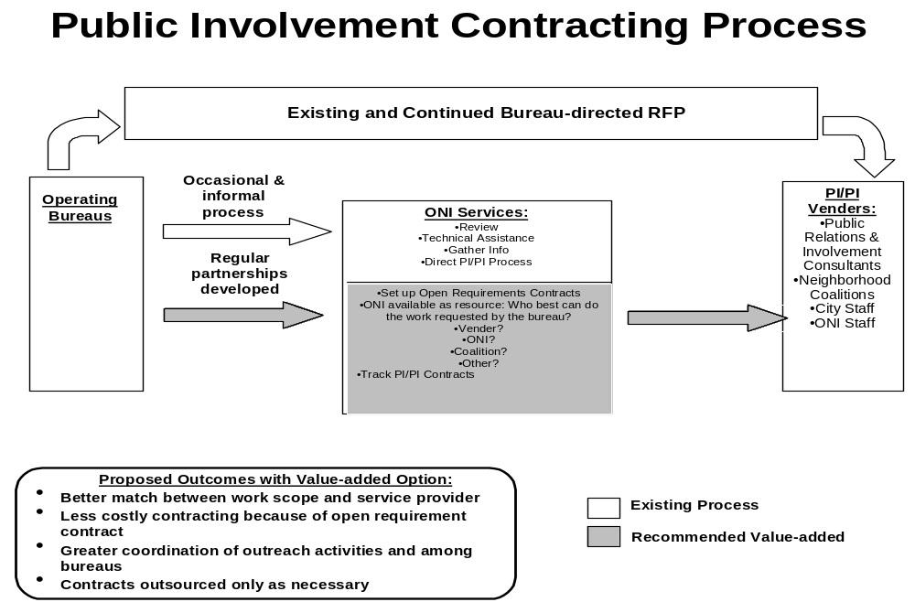
Figure 3. Proposed Public Involvement Contracting Process

Recommendation 2:
Coordinate administration of the majority public involvement/public information meetings, training, involvement opportunities, and policies in ONI.

This recommendation includes the majority of possible cost-reductions for the ASR recommendations. This is the Recommendation that would require the greatest shift in the “way the City does business.”

Description of services in Recommendation 2: There are three major parts of the implementation plan; each is described below:

- Stakeholder Identification
ONI would maintain and administer a central citywide public involvement database that would assist bureaus in identifying and contacting stakeholders for various projects that would be created and implemented by the bureaus. In cases where sharing bureau databases would not be appropriate (legality, confidentiality, etc.), bureaus would retain control of those specific databases and provide ONI with general information about their content. (An example of the type of database ONI currently is developing is included in Appendix II.)

Product produced for the bureaus:

A comprehensive citywide public involvement database that is updated and maintained regularly. A categorical list of identified stakeholder groups.

A receipt of individuals receiving notification.

Documentation of delivery times.

Coordination of notification and delivery services (both mail and electronic communication).

Use of GIS to target specific geographic areas.

Targeted notification to special interest groups, businesses, stakeholders, etc.

Value-added benefit for the bureaus:

Centralized source of information.

Minimized duplication of notices.

Increased public involvement in bureau projects (due to larger database).

Outreach tailored to meet bureau needs.

Reduction in administrative costs due to decreased mailings and duplicate notifications.

Bureau staff time on content issues increased as logistics redirected to ONI.

Value-added for citizens:

A centralized source of information.

Reduction in information overload.

Reduction in duplicate mailings.

Improved identification and notification of underserved communities.

Improved customer satisfaction through coordination between bureaus.

Process:

ONI conducts annual consultation with key Bureau project managers to learn about key stakeholder groups, identify potential “new” stakeholders, project timelines, special requirements, etc.

Bureau identifies individual project requiring notification.

Bureau contact sends request form to ONI specifying which of the above products is needed and a timeline.

Performance Measures:

Annually, ONI service evaluated based on:

Speed of response.

Accuracy of the information provided.

Results of the product produced, i.e. number of people at a meeting, number of responses to a survey etc.

Feedback from citizens, Council, Bureau project managers, etc.

Discussion of Bureau needs and concerns.

- Coordination and dissemination of general announcements, information to stakeholders about an issue, event, proposal, etc.
This section includes six separate services:

- Development of a citywide Public Involvement/Public Information Calendar.
The comprehensive calendar would list citywide events and include advisory committees, public meetings, forums, special events, neighborhood meetings etc. Bureaus would retain control over what they wanted listed on the calendar. (This calendar would be electronic, probably web-based, and be an expansion of the current calendar that ONI does on an “as needed” and “information-provided” basis.) It would be available for viewing and dissemination to the public. An example of Seattle’s web-based calendar is included in Appendix III. Preliminary discussions with BIT indicate that the technology and expertise exists to develop such a calendar in Portland.

Product produced for the bureaus:

A web-based calendar by day that could also be viewed by week and month.

Linkages to ONI Information and Referral Center database to facilitate communication and outreach (See ASR PI/PI Recommendation III.)

Printed copies of the calendar when needed.

Linkages to bureau, and neighborhood web pages.

Daily updates of information.

Media access.

Value-added for bureaus:

Centralized location for all public information, notification, and news efforts.

Improved coordination and cooperation of outreach events between bureaus, neighborhoods and other groups.

Less duplication and overlap of meetings.

Increased ability to broaden dissemination of information about city related events.

Bureau staff time on content issues increased as logistics redirected to ONI.

Value-added for citizens:

A centralized source of information.

Reduction in information overload.

Improved identification and notification of underserved communities.

Improved customer satisfaction through coordination between bureaus.

Easier access via web (available at Coalition offices, libraries, home, work, etc.)

Process:

Bureaus would determine a contact person who would relay to ONI what meetings; events, etc. needed to be posted on the calendar.

ONI would update the calendar daily and provide printed copies as requested.

Performance Measures:

A counting device would measure how many people accessed the calendar in a given period of time.

Increased attendance at public outreach events measured over time.

Feedback from citizens and Bureaus.

- Developing flyers for meeting announcements, disseminating meeting agendas and meeting minutes, if appropriate.

The bureaus would retain control of the content. ONI’s role would be to format information, partner notifications among bureaus where feasible, and distribute the information. (Notifications required by City Code, State Statute, etc would be retained by the bureau.)

Product produced for the bureaus:

Meeting announcements as flyers, postcards, fact sheets, email etc.

Consistent format and layout of notification based on consultation and approval by Bureaus.

Dissemination of meeting agenda and minutes for:

Flyers and notices for Standing Advisory Committees.

Public information meetings.

Task force meetings.

City Boards and Commissions.

Special events.

Public involvement sessions

Value-added for bureaus:

Increased collaboration among Bureaus.

Centralized location for City outreach efforts.

Professional graphic design advice on content and layout to increase ability to focus on content of information.

Improved coordination between bureaus, neighborhoods, citizens, and other groups.

Less duplication and overlap of meetings.

Broad dissemination of information about city-related events.

Ability to maximize use of electronic distribution methods as available.

Bureau staff time on content issues increased as logistics redirected to ONI.

Value-added for citizens:

A centralized “one-stop shopping” source of information.

Reduction in information overload.

Improved identification and notification of underserved communities.

Improved customer satisfaction as coordination between bureaus increases.

Process:

ONI meets annually (at a minimum) with bureau contact to determine regular notices needed and schedule.

Protocols developed annually (at a minimum) with Bureaus for format and distribution of material.

ONI provides bureaus with form to be used as needed for requests with notices not occurring on a regular basis or on an emergency basis.

Protocols developed annually (at a minimum) with Bureaus contacts for format and distribution of material.

Performance Measures:

Monthly evaluation form sent to bureaus to rate service.

Bimonthly interview with bureau contact person to rate and review service.

Protocols:

Match format with purpose of notice.

Match distribution method(s) with purpose of notice.

Content of notice remains responsibility of the bureau.

Identification of stakeholders.

Identify possible links with other bureau notifications.

Agree on timeline for dissemination.

- Coordination of public meetings.

Product produced for the bureaus:

Assistance to bureaus in scheduling public meetings as determined by the bureaus. Such meetings could include:

Advisory Committees.

Public information meetings.

Task force meetings.

City boards and commissions.

Special events: Assistance to bureaus would include:

Advice on scheduling (time, location, etc.)

Coordination with other bureau and neighborhood meetings

Arrangement of location logistics

Notification to neighbors, stakeholders, businesses, other groups, etc. as needed.

Dissemination of meeting agendas.

Dissemination of meeting minutes.

Value-added for the bureau:

Centralized location for all outreach efforts.

Improved coordination and cooperation between bureaus, neighborhoods and other groups.

Less duplication and overlap of meetings.

Broad dissemination of information about city related events.

Bureau staff time on content issues increased as logistics redirected to ONI.

Potential increase in attendance at public meetings due to better coordination, identification, and notification.

Value-added for citizens:

A centralized source of information.

Reduction in information overload.

Improved identification and notification of underserved communities.

Improved customer satisfaction as coordination between bureaus increases.

Better use of citizen resource (time).

Process:

Bureaus with ONI determine protocols for meetings.

ONI provides standardized request form.

Meetings scheduled and coordinated with other bureaus through centralized calendar and stakeholder notification.

Meeting logistics confirmed with Bureaus before notification and finalization.

Performance Measures:

Monthly evaluation form sent to bureaus to rate service.

Bimonthly interview with bureau contact to rate and review service.

Protocols:

Bureaus request ONI assistance in setting up meeting.

ONI matches meeting location and space with purpose of meeting, event, etc.

ONI identifies possible cooperation with other bureau meetings, events, etc. and works with Bureaus to resolve conflict, increase partnering, etc. (Ultimate decision on meeting remains with Bureaus.)

Bureaus and ONI:

Determine equipment needed for meeting (overhead projector, screen, etc.)

Determine set-up needed to enhance purpose of the meeting, event, etc.

Determine if refreshments are needed and what type.

- Coordinating public involvement and education opportunities

Product produced for the bureaus:

Increased City efforts to coordinate strategic planning and planning opportunities in order to maximize public involvement and minimize duplication of effort.

Coordinated public information and education opportunities on specific topics.

Creation of citywide public information and education opportunities.

Increase in citizen participation (numbers, diversity, representation) as partnerships and coordination increase.

Possible multi-pronged educational opportunities for citizens.

Value added for the bureau:

Centralized location for all education efforts.

Improved coordination and cooperation among bureaus, neighborhoods, and other groups.

Less duplication and overlap of meetings and information.

Broad dissemination of information about city related events.

Bureau staff time on content issues increased as logistics redirected to ONI.

Value added for citizens:

A centralized source of information.

Reduction in information overload.

Improved identification and notification of underserved communities.

Improved customer satisfaction as coordination between bureaus increases.

Process:

Bureau identifies education needs and opportunities.

Bureau contact sends request form to ONI specifying which of the above products is needed and a timeline.

Performance Measures:

ONI provides standardized information protocols to allow Bureaus to inform ONI about educational opportunities as needed, required, and desired.

Education opportunities scheduled and coordinated with other bureaus through the centralized calendar and stakeholder notification.

- Provide Bureaus with consistent citywide public involvement policies and procedures.

Product produced for the bureaus:

Regular meetings of Citywide PIPI lead staff (C-PIN) to network and learn about new methods, technologies etc. Use of C-PIN) as advisory group to:

Revise the “Outreach and Involvement Handbook for City of Portland Bureaus.”

Create of a PIPI “best practices” checklist.

Provide feedback and evaluation for ONI services.

To explore continued methods for administrative savings in the PI/PI area.

To coordinate PI/PI in other ways besides those included in basic ONI services.

Professional in-service on PI/PI topics to improve PI/PI.

Value added for the bureaus:

Consistent guidelines for PIPI.

Agreed upon standards for PIPI.

Ongoing education for PIPI staff.

Bureau staff time on content issues increased as logistics redirected to ONI

Value added for citizens:

A centralized source of information.

Reduction in information overload.

Improved identification and notification of underserved communities.

Improved customer satisfaction as coordination between bureaus increases.

Process:

ONI continues to coordinate and facilitate regular meetings of PIPI staff. PIPI staff will determine topics for consideration etc.

Creation of a committee of PIPI staff to review the current outreach handbook and make recommendations for change. This committee would also develop a PIPI checklist for review by all PIPI staff.

Develop a process whereby each bureau can integrate the standards and guidelines into new employee orientation.

Performance Measures:

ONI will develop an annual survey of bureau employees to determine satisfaction with the content and form of the PIPI meetings.

ONI will develop an annual survey form to seek changes, additions to the “Outreach and Involvement Handbook.”

- Provide strategic development services for bureaus.
Upon request, ONI staff would be available to bureaus to provide PIPI assistance to bureau project teams. (This service complements ASR PI/PI Recommendation I.)

Product produced for the bureau:

Issue identification.

Identification of potential stakeholders based on project impact.

Identification of appropriate outreach method(s) based on Bureau or Council goals.

Developing an initial project schedule for public involvement.

Advise on mechanisms for assessment and evaluation of public involvement.

Consultant services on strategic changes and directions for projects.

Discussion of outreach program, public involvement needs, as indicated by project and Bureau initiatives.

In-house consultation about ONI staff, coalitions, or other city-supported staff possibilities for outreach.

Value added for the bureaus:

Additional staff support for bureau PIPI employees.

Professional “in-house” city-staffed PI/PI consultation services.

Increased and improved access to stakeholders through central stakeholder identification system.

Improved coordination with other bureaus through centralized calendar and notification system.

Creation of a process that increases public involvement and is tailored to specific bureau needs.

Bureau staff time on content issues increased as logistics redirected to ONI.

Value added for citizens:

A centralized source of information.

Reduction in information overload.

Improved identification and notification of underserved communities.

Improved customer satisfaction as coordination between bureaus increases.

Potential for improved PI/PI services including clearer goals and understanding of the process.

Process:

Bureau and ONI staff would develop a project model using PIPI “best practices”, as described in such sources as the “Outreach Manual”, research, or other best practices, and the PIPI checklist.

Depending on project scope, create an interagency agreement or contract.

Performance Measures

Creation of benchmarks to measure success of project PIPI.

Final evaluation of project.

III. Evaluation Protocols
ONI, with cooperation from the bureaus, and with the C-PIN advisory group would develop an evaluation/feedback mechanism to ensure that the new systems are working as designed and to make any adjustments needed once implemented. Product and Process Benchmarks as described above would be used for each service and an evaluation form designed to measure successes. As indicated above, evaluation forms would be used weekly, biweekly, monthly or quarterly depending on bureau use of the service/product and the area of service provided. ONI will produce an annual report coinciding with the fiscal year to OMF and Council about the PI/PI process including suggestions for other possible administrative improvements and enhancements.

Benefits for Implementation of Recommendation 2:

Citizens and Bureaus would have a centralized source of information.

Professional staff time on content issues would be increased as time now allocated in Bureaus for logistics of public involvement could be redirected to ONI.

Minimization of duplication of effort, mailings, and information.

Dedicated resources could be used to increase stakeholder identification of underserved communities.

Maximized use of ONI’s other programs including MHRC, crime prevention, and mediation for stakeholder identification.

The City would have consistent practices for public involvement stakeholder databases and meeting organization.

Partnering among Bureaus on public involvement events would be maximized.

Citizens and Bureaus would have common calendar and database of information.

P&D charges would be saved as electronic notification would be simplified and maximized.

Web-based information could be improved as public involvement calendar, information, volunteer, and notification aspects of public involvement are coordinated through ONI.

Increased used of web-based technology such as shared databases, GIS, etc.

Challenges for Implementation of Recommendation 2:

Bureau staff would have to re-direct some time to working with ONI staff to set up database, notification requirements, etc.

ONI would be required to commit to understanding Bureau needs for public involvement.

Bureaus might lose some independence as Citywide efforts to coordinate, hold common meetings, combine information into one meeting, etc. are increased.

Some Bureaus, PPB and BES for instance, may feel that they currently partner with ONI for public involvement services through existing partnerships such as crime prevention. PPB originally shifted some funding for the crime prevention program when this program became a city service. BES funds are specifically allocated to various projects such as the Downspout Disconnection Program.

ONI would have to be responsive and available to work on efforts within Bureau timeframes. ONI and bureaus would have to work to ensure that efficiencies gained from new systems were not off-set by losses in bureaus due to lack of such things as “face-to-face” meeting ability with PI/PI support staff currently performing functions.

The team was unable to determine the breadth of this work and how much time it would take. Consequently, before implementation, ONI would have to work with the bureaus to determine the specific scope of work. The ability of ONI to handle the work given the recommended 4.0 FTE would have to be monitored and evaluated.

Implementation of Recommendation 2 would represent a significant change in the City’s “way of doing business.” There might be a short-term loss in productivity during the transition period until systems are established. A time line for implementation of this system is included in Appendix IV.

As we attempted to discern the current level of services, a matrix (included in Appendix V) was developed by the subcommittee addressing this Recommendation. Due to time constraints, complexity of the information required, and staffing issues, the data from this matrix is unavailable at this time.

Team members identified that currently ONI does produce a citywide PI calendar, does coordinate some meetings for bureaus as requested, and does maintain a stakeholder database. In addition, multicultural expertise was identified as a strength of ONI. As previously mentioned, the current calendar is only utilized by some bureau staff, on an inconsistent basis, and is has been targeted by ONI to be reduced to staff constraints because of the I&R consolidation with the County.

Recommendation 3:
Explore further consolidation of I&R functions within the City and increase the scope of the City/County I&R Center to relieve the Police Bureau of some I&R tasks. Utilize enhanced technology for city staff directory and I&R needs to reduce City/County I&R FTE.

A subcommittee was formed to develop this recommendation. Information and Referral Representatives from the Police Bureau, City/County I&R, and Bureau of Emergency Communications were included to explore options for improving I&R service in the City, identifying possible cost reductions, expanding the cost reduction recommendation included in the December 1 Cost Reduction Report, and discussing other options.

From the beginning, it was very clear that representatives did not agree with the cost reduction recommendations. Representatives from the City/County I&R and the PPB I&R felt that:
- Current staff had difficulty enough handling call volume without the transfer of calls from PPB to City/County, use of technology, or better coordination.
- PPB, BOEC, and ONI City/County I&R had drastically different functions. Although there was potential for savings and efficiencies, separating them out were not simple and would not negate the need for separate function.
- The call volumes and purposes of the three groups supported the current configuration of services.

As they met, the following issues were developed:

Common Ground for I&R service in the City
Police, BOEC, and I&R came to the following conclusions that would be agreeable for all groups:

The use of the Internet has potential as a way of distributing I&R information both internally and externally. Although this is not the most desirable form for information dispersal, it could create efficiencies. This method would allow external access via the Internet and would facilitate internal access via the City’s Intranet to a more expansive common resource list.

Consensus was reached on a shared database for information that is common to Police, BOEC, and I&R. The extent of the information contained in this shared database would have to be determined.

Recommendations for I&R service in the City
Based upon the ASR PI/PI Information & Referral subcommittee meetings, the following recommendations are suggested.

Explore how the Internet and Intranet can be used to create a central point for data to be accessed by Police, BOEC, I&R, and the public. For example,

A referral list on the internet would allow I&R staff (any of the I&R functions) to refer requestors to the internet if they have access to the internet, reducing time spent on calls and creating public awareness of the internet resource.

The public could, over time, begin going directly to the Internet for information, thereby reducing demand for I&R telephone service.

I&R, PPB and BOEC could go to a single intranet referral list so that referrals become more consistent and updating/maintaining the referral list would require only one functional area rather than three separate lists maintained by three different functional areas.

Calls statistics available at the beginning of the ASR process led to assumptions that may be invalid at this point in the process, given statistics available near the end of the process. Initially, it was thought that 1500 calls per month that were received by PPB could have been referred to/taken by I&R. The latest statistics indicate that the number is closer to 500 calls per month. It is believed that approximately 4% of calls currently taken by PPB I&R can be answered by both Police and I&R now. Therefore, the potential FTE savings associated with a shift of where these calls are answered may not be consistent with the original forecast.

If the proper protocols and training were put into place, more calls outside of each others’ core competencies could be cost-effectively answered and/or referred. More than half of all calls taken by PPB I&R are fully handled by PPB I&R; the calls are not referred elsewhere. Funneling all non-emergency calls to a single number would require either significant cross-training and access to restricted police information, or would create double-handling of the more than 50,000 calls that are currently directly handled by PPB. Careful cost-benefit analysis would be wise if this course of action is suggested.

Information related to what happens once a person has been referred/transferred is unavailable. Customer feedback about the effectiveness of referrals is unclear. The only quality check discussed was the periodic testing of the referral phone numbers (do they still work or not).

Other Options considered:
The subcommittee did consider other options during their framework plan discussions:

The group discussed how the “perfect” I&R program within the ASR framework might look. This system might include:

One stop shop of information and referral

One transfer to the content expert

Real person would answer the phone

Clear definitions of what work doesn’t fit into the system well

Understanding of the time it takes for a customer to reach a content expert – and the customer’s need and expectation.

Clear protocols for city wide referrals

The ability to own the call and not create an inappropriate demand for services

Internal awareness of the system

Information being shared by all involved stakeholders

Information sharing should be:

Central

Consistent in where referrals are sent

Of high quality

Responsive and responsible to the customer

Proactive

Meeting the demands and not impacting BOEC’s emergency call capacity

One point of contact

Training to include:

Updated information

Individual service lines

Overlaps in information and services eliminated

However, the subcommittee discussed a “one-stop shopping” idea but felt that it would not address the reality of the types of calls the City receives. The subcommittee also looked at a number of other options. These are included below and could be explored further. There was no consensus on these, but they do present possibilities for future discussions:
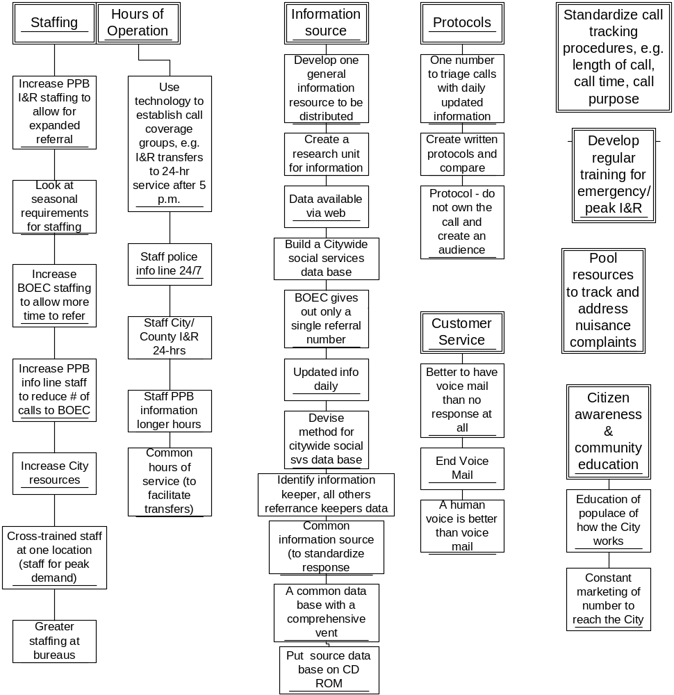

Reconciliation with December 1 Cost Reduction Report
The original recommendation includes the reduction of 2.0 FTE (1.0 in ONI and 1.0 in PPB). Any action on this recommendation must be tempered with:

New data questions original PPB recommendation. Original PPB data provided indicated that 1537 “social service calls” per month (roughly equivalent to 1.0 FTE) were handled by PPB I&R. To eliminate duplication, it was assumed that these could/would be handled by the consolidated City/County I&R program now that the City/County I&R program had increased its capacity and was addressing social service/county services. New information from PPB challenges this.

Technology and web-based I&R would decrease the numbers of calls coming into the City/County I&R Center. While this decrease may occur, it will take a year from inception to track whether the call volume changes.

Any changes in the City/County I&R program must be phased in given the newness of the expanded service. Data from the consolidated City/County I&R program (call volume, time, County vs. City calls, peaks, etc.) is tenuous given the newness of the expanded service. It will be a least a year before stable, consistent trends, patterns, service needs, etc. will be established.

Consequently, while the reductions originally indicated in the December 1 Cost Reduction may indeed be possible, they may not be possible beginning July 1, 2001 as further data, training coordination, database development, and statistics will need to be explored and reviewed.

Benefits for Implementation of Recommendation 3:

Continued coordination among City/County I&R, PPB, and BOEC will lead to better I&R, non-emergency, citizen service for the City.

Web-based exploration will enhanced City/County I&R services.

Common database will decrease staff time used to develop multiple, duplicative databases.

Maximized use of County social service referral possibilities.

Increased use of existing web-based services and Intranet.

Web-based technology will lead to decreased number of City staff calls at I&R Center.

Challenges for Implementation of Recommendation 3:

Concerns from PPB about how some non-emergency calls would be handled.

Required and mandated separation of functions and calling among City/County I&R Center, BOEC, and the PPB I&R Center will make any efficiencies difficult.

Coordination and handling of the other police-only calls (this is currently done.)

Decrease in FTE may not equate to actual call volumes lost and/or transferred as the 20% call volume attributed to City staff calls may not be completely eliminated.

Anticipated use of electronic versions of I&R services may result in decreased call volume or could actually increase phone calls as citizens become more aware of city/county services.

One-time start-up, web-development, BIT costs may be incurred to get the web-based services up and running.

Recommendation 4:
Establishment of Citywide Public Information Officer Position

Context:
The City of Portland provides direct and indirect services to the residents of Portland. Its policies and actions have regional interest, and impact. The City has a compelling interest in residents’ awareness of, and confidence in, City services. The policy question addressed by this recommendation is this: How can the City best leverage shared multi-bureau and City media relations and public information opportunities without lessening Bureau-specific information programs?

This recommendation proposes a position to develop and manage a central information strategy to provide residents and interested others access to information. The intent is to promote Citywide programs and services; and to assure prompt and appropriate media access related to City programs, events and situations for which the City currently has no designated staff.

Some City bureaus do maintain public information staff to address bureau-specific objectives. Police, Fire, Water, Sewer, Parks, Transportation and PDC are examples. This proposal neither replaces nor overlaps bureau resources.

One indicator of the need for an additional position with general Citywide responsibilities is the frequency with which the City “borrows” information staff from the bureaus in order to achieve citywide information objectives. Unique situations such as Y2K, weather-related emergencies, legislative support, ESA, and celebratory activities all require strategic responses.

Borrowed staff achieve results, but as an addition to already well-defined workloads. They are also only borrowed for unusual situations where public information is essential. There is no one to strategize or address the situations where public information efforts would be useful and desirable.

Media relations is a significant aspect of this job for the simple reason that most residents form their understanding and perception of City services based on the information they gain through electronic and print media reporting. Media reporting is immediate and timely, appears ‘objective’ and is readily accessible to Portland residents. It is one of the few ways residents receive information about the City’s performance without the extra effort of tracking the information down themselves.

Active media planning and interaction will offer residents greater access to information. It will offer better understanding of how the City works, how services are paid for, and how the City responds to the challenges of a more complicated and regulated world to improve residents’ quality of life. This is full-time work.

Citywide PIO Scope of Work:
This responsibility would be addressed with 1.0 FTE. This position would:

Serve as the primary contact with the media organizations, but not the exclusive contact.

Provide central coordination of citywide information, concerns and opportunities.

Serve as a resource to Commissioners, Council offices, Office of Management and Finance, Legislative Office, City Attorney’s Office, and under-represented city bureaus to provide:

Media strategy

Messaging

News releases, news events

Story placement

Information gathering and fact finding

Interview preparation

Coordinate with City bureau PIO’s on procedures, communication standards and serve as a resource to provide media and communication support as needed.

Provide citywide crisis management strategy and implementation.

Serve as the City’s spokesperson as needed, and identify appropriate interviewees within the Council or bureaus for specific topics.

Considerations: As this recommendation was developed, several areas were addressed:

Priorities:
Prioritizing the workload and the city’s issues is the single largest concern for this position. Conflicting priorities, the number of issues or opportunities and the difference of opinion of what is most important could result in conflicting messages to the public.

Recommendations for addressing Priorities:

Through a work session, City Council sets the communication goals and objectives for the year. The citywide PIO will provide a notebook of opportunities and issues, not unlike the Legislative model, and Council will discuss messages, priority and identify a lead on each topic. Categories would include National, Statewide, Local and Special Interest (finance, tourism, economic development, etc.). It is recommended that City Attorney, Legislative, Auditor and OMF be represented at this work session.

As unforeseen opportunities arise, they will be measured against existing Council communication objectives to determine if they will receive action.

Bureau Communications:
The citywide PIO position is a complement to, not a replacement for, Bureau PIO positions and functions. Programs and services within bureaus that have communication positions are benefiting the public by providing essential information about access to services, improving public trust through communication and building understanding of the priorities of a bureau.

We also need to lay a foundation of public understanding for the City as a whole entity, its goals, decisions, policies and projects. The public does not differentiate between governments and sees the City as one organization, not many individual bureaus working independently of each other.

Recommendations for addressing Bureau Communications:

The citywide PIO will facilitate a team of bureau PIO’s to regularly discuss issues, share resources, look for opportunities to partner and improve communication services. This team will be responsible for the development of procedures and communication standards. These meetings will also reinforce the need to incorporate overall city goals and messages into bureau communications.

Communication objectives for Council members
This position cannot be responsible for political messages. Council members and their staff will continue to handle their own media relations, interviews and outreach. The citywide PIO will be available as a resource to assist in media, event and communication strategies.

Recommendations for addressing Communication objectives for Council members:
- This position will coordinate with Council and staff on all citywide communication strategies to define roles and responsibilities.
- Media requests will be directed to Commissioners/staff on all policy development, Council agenda items and initiatives. The citywide PIO will provide the media with only the basic facts, budget information, history and implemented policies, programs and services that relate to these issues. The position does not advocate for or against any pending issue.
- City Council will set communication objectives each year. It is recommended that portfolio assignments guide the PIO in the direction of media to a specific commissioner for comment.

Physical Location of the Citywide PIO Position:
For this position to be successful and credible with the public, it must remain separate from the political process and objective in its relations with the media. There are three City functions that provide a direct resource to Council and City Bureaus.

Recommendations for Physical location of Citywide PIO Position:
- The Office of Management and Finance now reports to the entire Council. Most of the communication priorities set by Council will need to coordinate with OMF. Resources and support are available as well as direct access to needed information. OMF is a resource function of the city to bureaus and council. We recommend the position be located in OMF and report to the Director.
- An alternative recommendation locates this position in the Government Relations Office, reporting to City Council and coordinating with City bureaus. The PIO position would support Government Relations Office needs. The downside to this location is that administrative and office resources are already stretched thin and the accommodation of another position may overburden the office.

Expectations:
The creation of a new position may also create an expectation that this position will meet all the communication needs and ideas of the entire city organization. Obviously, a single position will have limited time, resources and media interest.

Recommendations for Expectations:
- Council sets yearly communication objectives. Incoming requests for service will be measured against these objectives. These will be communicated Citywide.
- The PIO will make initial contact will all City offices to assess needs and opportunities and reinforce the role of the position and communicate the services and limitations citywide.

Budget and Responsibilities:
This position is 1.0 FTE funded at an equivalent level to the Communications Director of the Portland Development Commission with City benefits and 15% materials and services. Total personnel and M&S budget for the Citywide PIO is $115,000.

Initial needs for the position include:
- Office
- Computer
- Printer
- Cellular Phone
- Pager
- Access to Xerox
- Access to transportation(fleet rental)
- MOBA Media transcript services and subscriptions to local publications.
- Basic rental services (sound, tables, other services) to support news events
- Mailing/printing

The Bureaus involved in each issue would fund major events and initiatives. An example is Your City Your Choice budget outreach whose needs included advertising, research and support.

Funding:
This recommendation is the only one coming out of the ASR PI/PI process with wide acceptance by the team. It is the only recommendation that requires additional funding and is the only one not funded within the target reduction and cost reallocation. Two options were developed by the subcommittee for funding this initiative:

Find the resource within the existing ASR PI/PI initiative. The ASR recommendation includes cutting 8.5 positions across the Bureaus, with a restoration of four positions to ONI. One option is to allocate 2.5 of those 4 positions to ONI and use the remaining resource to fund the citywide PIO position. This, of course, would provide alternative difficulties for implementing Recommendation II above.

Regard the position as a city resource position and fund it through additional overhead charges to the bureaus.

Either one of these options would be an equitable way to pay for services that are currently performed but usually at the expense of one or two Bureaus who are requested to loan positions when the City needed it and all city agencies benefited from the efforts.

Benefits for Implementation of Recommendation 4:

Key citywide messages developed for the city.

Full-time commitment to better media relations.

Increase in positive relationships with media.

Ability to present positive citywide issues to citizens.

Increased ability to coordinate current communication among officers/PIO staff in Bureaus

Addition of PIO services for Bureaus that currently don’t have a PIO and need occasional public information/media relations support.

Challenges for Implementation of Recommendation 4:

Coordination within the City’s decentralized portfolio system.

Placement of position—which Bureau or Office?

Establishment of priorities and staff time allocation among Bureau projects, Citywide events, and public involvement opportunities.

Funding for the position: Administrative support costs may need to be included in the projected budget. Option 1 above would subtract needed resources needed to fully implement Recommendation II.

Additional recommendations:
As indicated above and in the December 1 Cost Reduction Report., the ASR PI/PI team considered many options in its deliberations. The following were considered but not included in the December 1 Cost Reduction Report because of difficulty of determining potential cost savings or because they did not meet the guidelines provided by Council and OMF. Most of these recommendations were included in the “Minority Report” submitted with the December 1 Cost Reduction Report.

Some of these recommendations are duplicative of the original four recommendations or have been included in the refinement of the recommendations during this phase of the ASR process. However, all of these additional recommendations are included here to indicate the “spirit of the ASR” process. Other “new recommendations are included because they have merit, and have potential savings. Moreover, some—regardless of cost savings--may be good city PI/PI practice.

Recommendation 5
Allocate target budget reductions to the affected bureaus based on overall budget, rather than FTE reductions.

This recommendation was not included in the December 1 Cost Reduction Report as it did not meet the guidelines of the ASR from Council and OMF. Many ASR PI/PI team members advocated for cross-the-board allocations. OMF guidance and direction did not allow this as a recommendation.

Bureau-level decisions about any budget reductions in PI/PI: One of the intents of this recommendation is to maintain decisions regarding implementation of ASR cuts with each Bureau. This was the intention of the Central Services Manager with Recommendation II above. Although the reductions were based on a FTE allocation, it was the clear intent that Bureaus would determine how to meet the dollar reductions—whether through a cut in actual FTE or through other means.

Recommendation 6:
Improve CIP Coordination:

Encourage public involvement and outreach planning in the existing Citywide CIP coordination effort. This will support development of collaborative public involvement/public information plans. Initiate a similar effort for other planning initiatives.

Establish a standard practice for development and implementation of collaborative public involvement plans in conjunction with the Citywide effort to coordinate schedules for capital and planning projects by geographic area.

This recommendation was suggested in a “Minority Report” as a possibility for meeting most of the target reductions; thus it was an alternative to Recommendation 2.

This recommendation is already being implemented. With the “River Renaissance Project,” the Bureau of Planning has been charged by Council to coordinate the planning for all citywide projects affecting the Willamette River. BES staff is facilitating the coordination of project implementation for major CIP projects, and PDOT staff are coordinated implementation of specific CIP projects affecting the bridges and associated right-of-ways in the City. Recently, ONI was asked to participate in this CIP coordination effort. BES lead staff are developing a “Public Communication Fact Sheet Template” to gather information about PI/PI for this CIP coordination effort. The draft is included in Appendix VI. Interestingly, this independently developed survey includes many of the same questions that have been asked in the ASR survey and the information-gathering matrix developed for Recommendation II.

To date, public information/public involvement have not been directly coordinated, mostly because these CIP coordination efforts are new or are just beginning. For instance, while ONI is included in the River Renaissance Directors’ team, implementation and true coordination of PI/PI in this project is still in its early phases.

Benefits for Implementation of Recommendation 6:

Better coordination of PI/PI in CIP is clearly a concept that could:

Produce clear cost reductions,

Eliminate unnecessary duplication

Improve the perception of non-coordinated services among citizens

Utilize existing city-funded resources: City staff, ONI, coalitions more effectively.

Many ASR PI/PI team members felt that full implementation of this could conceivably produce enough savings to meet our ASR target reductions.

Challenges for Implementation of Recommendation 6:

Although the ASR PI/PI team felt true—and potentially significant savings—could occur through CIP coordination, it was impossible to capture those savings for the December 1 Cost Reduction Report. It is clear that tracking and documentation will need to occur to capture the true savings. However, this recommendation can still be implemented with direction from Council and OMF for documentation and tracking.

To date, it has been difficult for bureaus to provide clear, simple information about PI/PI services. This may be because PI/PI costs are interwoven throughout projects and are difficult to separate.

Recommendation 7:
Encourage bureaus to consult with ONI on all public involvement processes and invite ONI to bid on all public involvement contracts.

This concept is now included in Recommendation 1 above. There are difficulties, however, with ONI “bidding” on city-advertised PTE contracts:

- If ONI were to compete with the private sector for publicly advertised PI/PI contracts, the contracting community will likely question the fairness of this approach.

- Questions regarding the manner in which ONI allocates overhead and direct costs are likely to be raised.

- In addition, outside contractors may be discouraged from spending time and effort to propose on a project for which the City is also competing.

- In general, contracts for Professional Technical and Expert Services should not be advertised and/or secured if the services can be reasonably supplied by City personnel.

Recommendation 8:
Encourage ONI to coordinate a citywide discussion to develop common terms, understanding and expectations for outreach processes along with standard guidelines.

This concept is a role that ONI has tried to take on in the past and is included in the framework of Recommendation II.

Benefits for Implementation of Recommendation 8:
This could result in service improvements, be accomplished within existing staff and budget, and result in greater understanding of the variety and scope of existing programs.

Challenges for Implementation of Recommendation 8:

As mentioned in the “Roles and Responsibilities” section above, the role of ONI as a Central Services Provider, and thus the lead agency for coordinating this discussion has not been clear. Council direction in this area is warranted.

Coordination of this discussion could clearly take place with implementation of Recommendation II above. Without additional resources, however, staffing an ongoing citywide process would stretch current, limited resources.

Recommendation 9
Encourage ONI to coordinate a citywide discussion to explore development of a common stakeholder identification database with citywide availability.

This concept is clearly included in Recommendation 2 above. Already, ONI has asked the City Attorney’s office to provide guidance on confidentiality issues around the sharing of inter-bureau data. In addition, ONI has begun discussions with BIT around technological needs for improved database management. ONI has consolidated its databases, developed a common stakeholder identification database for its constituents, and put its “Neighborhood Involvement Directory” on the web (saving thousands of dollars in P&D and staff time).

Benefits for Implementation of Recommendation 9:
This could be a cross-bureau process, accomplished within existing bureau budget and staff. If the workgroup found common benefits they could recommend an implementation process and propose a model for equitable cost-sharing.

Challenges for Implementation of Recommendation 9:

As indicated in Recommendation VIII, and in the “Roles and Responsibilities” section above, the role of ONI as a Central Services Provider, and thus the lead agency for coordinating this discussion has not been clear. Council direction in this area is warranted.

Coordination of this discussion could clearly take place with implementation of Recommendation II above. Without additional resources, however, staffing an ongoing citywide process would stretch current, limited resources.

Recommendation 10:
Charge BIT and ONI to coordinate a citywide discussion on how bureaus might use information technology to facilitate public involvement and public information.

This might also include exploration of “e-government” services to the community.

ONI and BIT have already been in discussion on how ONI can use information technology to improve ONI functions. In the last year, we have consolidated databases, improve email vs. “snail mail” possibilities to reduce costs, provided web access email to all ONI outstationed employees, and implemented an electronic and web-based version of our “Neighborhood Involvement Directory.”

Recommendations 2 and 3 above include increases and improvements in the implementation of information technology for administration of PI/PI services and I&R services. Clearly, web-based improvements will enhance the delivery of PI/PI services and lead to potential savings, efficiencies, and potential savings.

Benefits for Implementation of Recommendation 10:

Widening the discussion of how information technology would certainly improve the delivery of PI/PI services.

Recommendations from this work process might include further implementation of the “e-government” concept.

Challenges for Implementation of Recommendation 10:

Difficult to capture potential savings for ASR cost reduction phase. This is the rationale behind the cost estimates for the reductions included in the December 1 Cost Reduction Report.

Without additional staffing included in Recommendation II, staffing an ongoing citywide process would stretch current, limited ONI.

Service and Performance Standards
As mentioned in Section III, currently, the city has few—if any--citywide policies. Chapter 3.96 establishes ONI as a bureau, some bureaus (e.g. Water, PDOT) have internal bureau policies for PI/PI, and Council has provided direction and budget for specific PI/PI processes.

Few Service and Performance Standards:
The ASR process found very few citywide service and performance standards existing in city PI/PI efforts and programs. The closest example of a citywide policy—besides Council’s 1996 resolution and “ONI Guidelines” mentioned in Section III above—is the ONI-developed Citizen Participation Handbook which has not been updated since 1997 but is used by some bureaus on a voluntary basis. (ONI will begin revising this in late spring 2001.)

Current Status
City Staff engaged in PI/PI inevitably follow professional training standards, ethical obligations, and maintain the highest integrity in the PI/PI process. City PI/PI staff are dedicated, well-respected, and work to design and implement good processes. And Portland has a strong national and international reputation for citizen participation. However, over the years, citizens, coalitions, neighborhood associations, and community partners have not always agreed with the process and/or have questioned how the process was designed and implemented.

Mandates Driving PI/PI
There are some specific instances where standards and legal requirements exist. As the ASR PI/PI team met, we discussed the myriad of factors that drive PI/PI and determine standards for what, how, and when specific PI/PI projects and programs are accomplished. Examples of the mandates that drive PI/PI include:
- ONI – City code
- Guidelines for Neighborhood involvement
- Police – Council as part of transition to community policing
- Planning comprehensive plan
- State land use plan goals
- ORS
- Measure 56 (Notifying property owners)
- Public meeting laws
- Council – citizen involvement resolutions, directives, etc.
- Progress board benchmarks
- Service Efforts & Accomplishments Report (Auditor’s Office)
- Federal requirements
- Cultural expectations for strong citizen participation in Portland

Recommendation-

Establishment of Citywide Standards and Assurances:
Despite these specific mandates (that often have required standards), as a City, there are no definitions to how PI/PI should be designed, when it should be followed, what should be the goals, or evaluation criteria. Establishment of standards has generally been decentralized and left to the discretion and direction of the individual bureaus.

The lack of standards and standardization was one of the difficulties identified by the ASR PI/PI team. For instance, the “Minority Report” identified “considerable concern…with the incomplete understanding of current programs; a lack of problem-identification; and the absence of shared criteria for a good solution with which to evaluate the recommendations.” Further, the “Minority Report” recommends that to “develop better ways of achieving public information and involvement on a citywide scale, we would need to:
--Understand the range of current programming
--Establish criteria for standards of improvement; and
--Measure alternatives against the criteria

Recommendations 2, 8, 9, and 10 would include the development of standard policies, procedures and performance standards for the City. These would be done through collaborative effort among Bureaus with ONI as the lead facilitator. All policies and standards would be reported back to Council for approval and implementation. Such standards would be used to track PI/PI services and monitor potential efficiencies and future cost savings.

Examples of needed city policies include:

Establishment of Council Assurances:
As part of this ASR process, Council direction is needed on the desire and direction for the establishment of PI/PI standards. In addition, Council direction is needed to clarify the role of ONI.

As—and if—ONI moves to become a more centralized provider of PI/PI services, it is imperative that Council establish firm guidelines, assurances, and direction to ensure that all centralized services ONI takes on are provided fairly, equally to all constituents and bureaus, and as far as possible away from political influence. These “assurances” would become part of ONI’s operating definition and code-defined mission.

Sample Assurances
To this end, Council should approve assurances such as…As a central service provider, ONI will:

Support Council objective to maintain a strong public involvement process in City programs and initiatives.

Work with Elected Officials and Bureaus to implement the best public involvement and public information practices.

Provide each ONI customer (Council offices, Bureaus, outside partners, etc.) quality public involvement services with the same standards, practices, and policies.

Adhere to all City Code requirements, Council resolutions, Council directives, and City policies.

Develop in partnership with other Bureaus, citywide standards for service approved by Council.

Administer all central administrative public involvement services, in a responsive, neutral, and fair manner.

Establishment and adoption of “Best Practices” for PI/PI:
A citywide collaborative effort among bureaus, with direction from Council, should establish “best practices” that can be implemented by bureaus. These “Best Practices,” once established, could form the basis of individual bureau policies. Just as Human Resources establishes parameters for effective human resource policies, this PI/PI “Best Practices” would provide consistency and understanding across the City. For instance, the City might develop a standard of ethics for PI/PI. An example of a “Code of Ethics” from the International Association of Public Participation” is included in Appendix VII.

Development of standard operating procedures:
As much as possible, the City would benefit from having standard procedures, policies, and timelines for PI/PI. Established protocols could be established through citywide collaboration and would help bureaus make decisions about how to implement PI/PI processes. Several bureaus (eg., PDOT, BES, and Water) have these guidelines. ONI is in the process of developing standard implementation schedules that could be used to develop interagency timelines for projects. Once these timelines are established, bureaus, Council offices, and agencies would be clear on when, how, and what is needed for public involvement processes. An example of such a timeline is included below.

Technology

The technology needs of PI/PI are few given that most of the work involves working directly with the public. People to deliver the services—especially public involvement—will always need to be the greatest City investment. However, embedded in Recommendation II and III (the ones with the majority of cost reductions) are specific use of technology and IT solutions to maximize efficient PI/PI administration. In addition, Recommendation I includes support for data tracking in Purchasing and the other recommendations include increased sharing of resources using web-based services.

Specific technological solutions included in the Recommendations are:

- Support for the development in Purchasing of a PTE tracking system to gather data on PTE contracts for PI/PI.
- Development of web-based citywide PI/PI calendar available to both citizens and staff.
- Development of web-based information and referral services with a dedicated search engine.
- Utilization of common stakeholder databases to minimize duplication of mailings and staff time.
- Reductions in “snail mail” notifications and increased use of email wherever possible.
- Increased use of web sites as public information vehicles where possible.

It should be noted that Multnomah County has expressed interest in providing in-kind services for the development of the web-based I&R services for the current City/County database which could be used by PPB and BOEC. However, with the current County budget shortfall, additional City IT services may be needed.

Financial Issues
PI/PI will always need to be led by City project managers. Outside income for PI/PI is probably limited due to the nature of the services. Some potential sources of revenue include:

- Federal and foundation grants. These grants tend to focus on specific projects or areas but could be a way for the city to augment or expand PI/PI for a limited time.
- Expand Information and Referral to include other jurisdictions. ONI has already had preliminary discussions with Metro about providing I&R services. These types of partnerships could bring in additional revenues leading to better service efficiencies although additional staff might be needed.
- Partnering with other agencies doing PI/PI. For instance, if the City’s CIP projects were geographic based, we might consider partnering with the Port of Portland on their N/NE projects near the airport or NW projects along the river. Outreach and public involvement processes for Planning could partner with Metro.

Implementation Overview

Key Issues:
There are key issues that need to be addressed in order to implement any of these changes and especially any changes leading to immediate cost reductions. The following need to be addressed before any possible cost reductions are allocated:

- Determine whether public involvement and public information are administrative or direct services. This will affect the need for ASR inclusions, reductions, or administrative changes.
- Decide which aspects of public involvement and public information are central services.
- Define the role and mission of ONI—is it the City’s public involvement bureau?
- Confirm individual Bureau’s roles and responsibilities when it comes to delivering public involvement and public information services.

Timeframes for implementation:
Once the above issues are resolved, implementation of the any or some of the proposed recommendations may not be necessary. Assuming the full implementation of the Recommendations, here is a tentative timeline:

Date | Process
January 2001 | CIP coordination with ONI begins (Recommendation VI)
February – June 30, 2001 | Council deliberations and decisions about PI/PI policy and budget
February – June 30, 2001 | As appropriate, continued discussions with ASR PI/PI team and Bureaus about implementation of the recommended changes.
July 2001 | Council adopted assurances, standards, or necessary code changes take effect.
July 2001 | ONI begins citywide discussion to identify common stakeholder concerns, overlaps, solutions (Recommendations II and IX)
July – August 1, 2001 | Hiring of staff to implement Recommendation II
June - July 2001 | Development of “open competitive” contract for implementation of Recommendation I
August 2001 | Development of pre-qualified bidders list
August – September, 2001 | Formulation of procedures and protocols for implementation of Recommendation II
July – August 2001 | PIO position description finalized, position recruitment and hiring
July – August 2001 | ONI begins citywide process to develop “best practices,” policies, etc. included in Recommendations VII – IX.
August – July 30, 2001 | Citywide process for the development of PI/PI policies and standards continues. Council adoption upon completion.
March – September, 2001 | As appropriate, Phase I discussion of issues involved in implementation of Recommendation III continues.
March – June 30, 2001 | Discussion with County regarding I&R cost formula, agreement on metrics, etc.
March – August, 2001 | Development of web-based I&R database
September 2001 | ONI and BIT initiate citywide discussion on technological issues and solutions for PI/PI
September – December, 2001 | Planning for implementation of Phase II changes in I&R services based on information gathered in Phase I
January – March, 2002 | Phase III: Implementation of I&R changes.

Estimates for necessary investments to achieve new service model: As previously mentioned, the only investment that may be required will be IT services to develop web-based I&R services if the County is unable to provide these in-kind services.

Evaluation of any PI/PI administrative changes:
One of the key needs after any significant implementation changes in PI/PI will have to be an evaluation of the changes and the “new” system. This evaluation should include both quantitative and qualitative measures. Recommendation 2 above includes significant feedback loops and evaluation measures. However, a systemic look is also needed to evaluate whether these changes have attained the goals of:
- Improving public involvement and public information for citizens and bureaus. Ensuring the City is doing these administrative and support functions in the most efficient and cost-effective manner
- Exploring how technology could improve public involvement and public information administration
- Meeting target reductions

One of the problems—as outlined in earlier sections--will be defining the current system in order to offer a comparison. However, once the decision is made to proceed, the ASR PI/PI team should be re-convened to determine:

Levels of expectations
- Performance measures
- Measures for qualitative data from stakeholders, customers, and/or citizens.
- Key indicators to measure the impact on PI/PI services

An evaluation plan should be in place before the implementation changes are made so
that in 12-18 months, ONI can report back to Council the results of the implementation.

